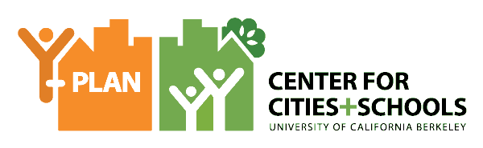

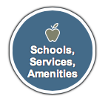
Project for Change at Brooklyn Lab School
Brooklyn, NYC
Brooklyn Lab School
12th Grade Economics

QUESTION
How Can Insight & Data Collected From the Students here at BLS Help Develop our School’s New Multimedia room into a Health, Safe, and Accessible Place for All Students to Pursue Creativity?

COMMUNITY OF PRACTICE
- Instructor: Mr. Pierson
- Students: 12th Grade Economics
- Client(s): Principal Henry

YOUTH DRIVEN DATA AND INSIGHTS
Site Mapping & SWOT analysis of empty media storage room
- Room is currently used as a storage room, but has lots of potential for student use with a classroom area, radio studio, office, and storage space.
Survey of BLS student body
- 67.6% of students who took the survey believe that a multimedia room would be a good idea
- 61% of students think that the multimedia room would offer students an opportunity to learn new skills and entertain peers

RECOMMENDATIONS
SHORT-TERM (1-6 Months)
- Remove all of the equipment and miscellaneous items that are already present.
- Conduct an inventory on the items that could be salvaged, and discard those that cannot be.
- Find funds in order to build the multimedia room.
- Work with community partners/other school to obtain ideas.
- Design a model of the room to show our vision for change.

LONG-TERM (1-3 Years)
- Initiate the grant writing process
- Contact local radio stations
- Create a student internship program to run the multimedia room

NEXT STEPS AND SHARED ACCOUNTABILITY:
We are seeking grants and donations so we can pursue our multimedia room and give our youth more opportunities in discovering new talents and new ways to express their creativity and also possibly pursue a future career in the media industry.

