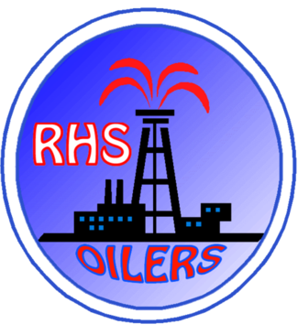
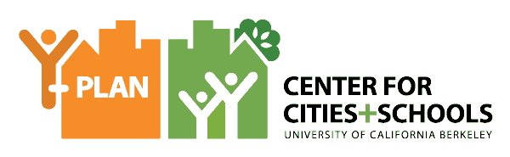

Y-PLAN Policy Brief 2017

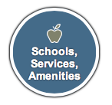
Building a Healthier School Climate
Richmond, CA, Richmond High School
10th Grade Health Academy

ISSUE
Rich Seeber, Lead Y-PLAN Teacher at Richmond High School, engaged his two Public Health Solutions classes in the Health Academy to develop proposals for improving school climate issues on campus. The school has set up a Climate Action Team composed of teachers and administrators to address such issues.

QUESTION
Why is school safety a public health issue? Is Richmond High School a safe space for all students? How can we, as school administration, continue to make Richmond High a safer place for all students?
RECOMMENDATIONS
Throughout the Fall 2016 semester Mr. Seeber’s students learned about public health, safety, feelings of wellness in school, and equity. They developed a survey for their Health Academy peers, but ultimately decided to distribute the survey school-wide, obtaining responses from 180 students. Through their in-class lessons and activities, they were reminded that school climate is an indicator of an equitable education.

Students learned that various social, emotional and systemic factors (like poverty or racism) create different health outcomes for different populations. With this in mind, they developed proposals for the new committee to consider for future implementation.
COMMUNITY OF PRACTICE
Instructor: Rich Seeber Students: 10th Grade
Community Partners: Contra Costa Health Services Department
YOUTH DRIVEN DATA AND INSIGHTS
Mr. Seeber’s classroom lessons aligned the Public Health Solutions curriculum from Contra Costa Health Services and Y-PLAN Roadmap to engage over 60 students in this project.

PROJECT CLIENT
Richmond High School Climate Action Team:
This is a new committee on campus with one teacher and school administration represented. One goal for this project was to begin shaping what this committee would look like in the future, what their priorities should be and possible solutions inspired on youth experiences and survey results.

RECOMMENDATIONS

SHORT-TERM (1-6 Months)
Students recommended simple solutions that could be implemented in the next couple of months. Many of these are also relatively inexpensive and only require small adjustments to school operations and conditions.
- Add toilet paper and soap in the bathroom throughout the day. Students shared that in the morning the bathrooms are in good condition but by lunchtime, there is no more toilet paper for the rest of the day and the soap containers are empty.
- Fix broken stalls. Many times students are late to class because they need to stop at the restroom between classes and the bathroom stalls are broken, so there is a line of students waiting for 1 or 2 stalls.
- Fix damaged lockers. This was a popular recommendation from the student body. They disliked the condition of their lockers and saw this as disrespect to their safety and privacy. They shared photos of lockers that were jammed or too far from the student’s classes, so students feel forced to share lockers with their friends.
- Paint walls to make classrooms more engaging. Most classrooms in Richmond High School have no windows; students suggested adding windows to the hallways to avoid bad smells, and to allow more natural light to come in.

LONG-TERM (1-3 Years)
- Add drinking water fountains. Students were concerned with water access on campus and suggested adding more filtered water fountains to encourage students to bring reusable water bottles and drinking water.
- Improving and repairing damaged facilities such as locker islands, walls and ceilings. The decaying state of the building’s infrastructure raises concerns about the physical safety of students. It also adds to the lack of student pride and the collective campus identity, which translates in issues such as graffiti, tagging and littering.

NEXT STEPS AND SHARED ACCOUNTABILITY:
Students will present their findings and proposals to the rest of the RHS Climate Action Team in the weeks to come. They will also present to the WCCUSD Superintendent in by the end of the semester. The representatives from the RHS Climate Action Team who were part of the final presentation panels were interested in hearing more from the students about the reasons behind their proposals, specially those that could be addresses soon and with a small budget. The panel members had multiple questions for the students on their personal experiences around campus and how it related to the survey results they found through the project. Later in the spring, Mr. Seeber’s students will also present in the Richmond Y-PLAN Summit alongside Y-PLAN scholars from other schools in City Hall.

A small cohort of these students will participate in a Spring Y-PLAN project with the Trust for Public Land about climate change, resilience, and new technological tools like Geographic Information Systems (GIS). Students will advise TPL staff on the development of layers of health and resilience indicators for this GIS platform. The Trust for Public Land is conducting this project for the City of Richmond to use.

