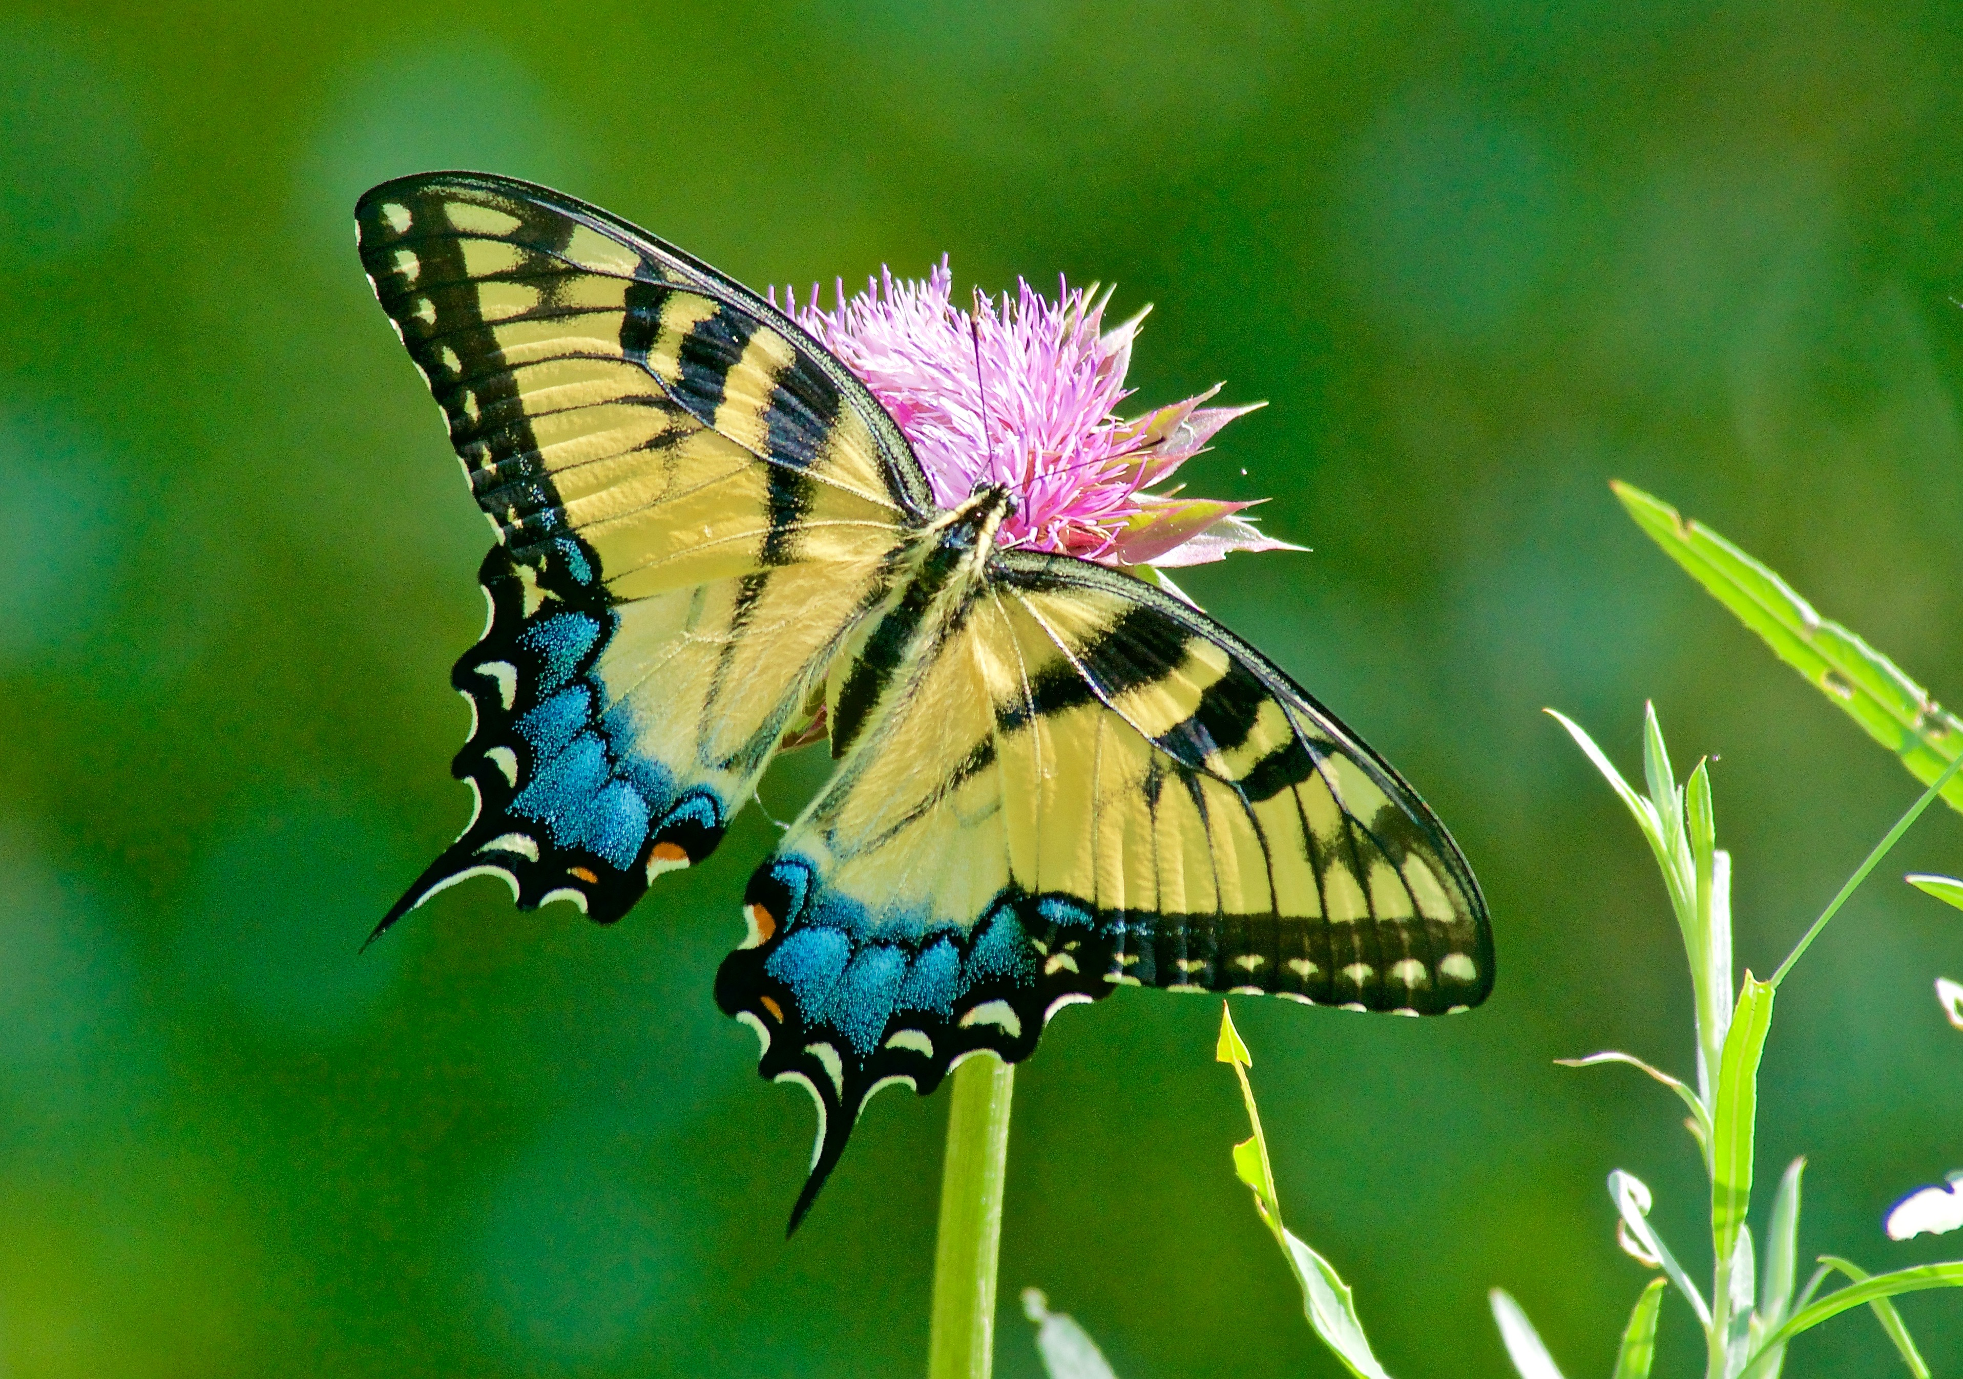
Tigers on Market Street
Carol Siddle’s First Grade Class, Sloat School, SF
Shirl Buss, Y-PLAN Elementary, UC Berkeley

These first graders built model skyscrapers to frame the Market Street corridor from the Ferry Building to City Hall. Concurrently, they learned about how the Western Tiger Swallowtail butterfly has found a home in the London Plane trees that line the busy thoroughfare. Tall buildings and trees resemble the butterfly’s natural habitat — river canyons. The students took on the challenge—given to them by Amber Hasselbring and Liam O’Brien of Nature in the City and Damien Raffa of the Presidio Trust—to retrofit the public spaces along the street to raise awareness about the butterfly and to support its habitat. The children’s proposals for “urban acupuncture” include butterfly-themed bike paths, seating, and bus shelters. To educate the public about Tiger Swallowtails, they also envision pop-up outdoor classrooms, mini-museums, parklets, and other interpretive features promoting creative interaction about wildlife corridors and nature in the city.

Y-PLAN Elementary, an initiative at the UC Berkeley Center for Cities + Schools, builds the foundation for academic success, college and career readiness, and civic activism for K-5th grade students. The Y-PLAN methodology engages children in generating innovative solutions to authentic community development challenges. Throughout the process, students apply core academic skills—as they think critically, use their voice, and experience themselves as active participants in shaping the future of their cities and schools.

Family Friendly San Francisco

Responding to the challenge posed by the SF Planning Department, these first grade students worked in teams to create posters articulating their thoughts, feelings, hopes and desires for the urban environments we all occupy. Each team took on a theme: Transportation, Safety, Adventure, Learning, Stewardship, Equity, Wild Space, Fun, and Diversity. They studied inspiring examples of public spaces in cities around the world and then translated their dreams and visions into collages, drawings, and writing. They have concepts to give us about how to enhance the city in ways in which they — and all of us — can thrive.

Children want to learn, act and contribute. These young children prove, that when asked, children eagerly respond to opportunities to think creatively about the environments we all occupy. They have much to offer us about re-thinking our created spaces. When given a framework within which to generate solutions and recommendations, children produce ideas about the built environment that are fresh, insightful, imaginative, and humane.

