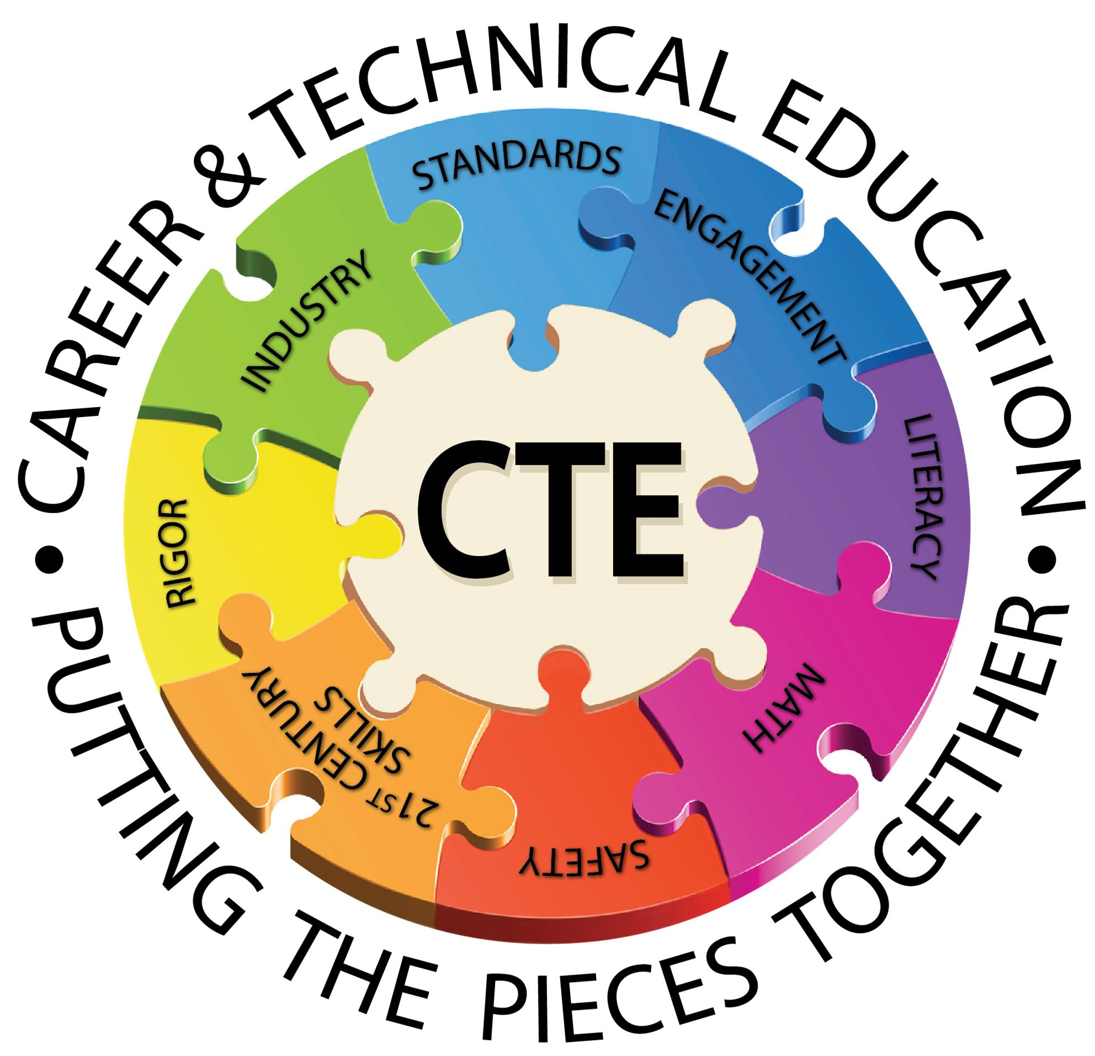
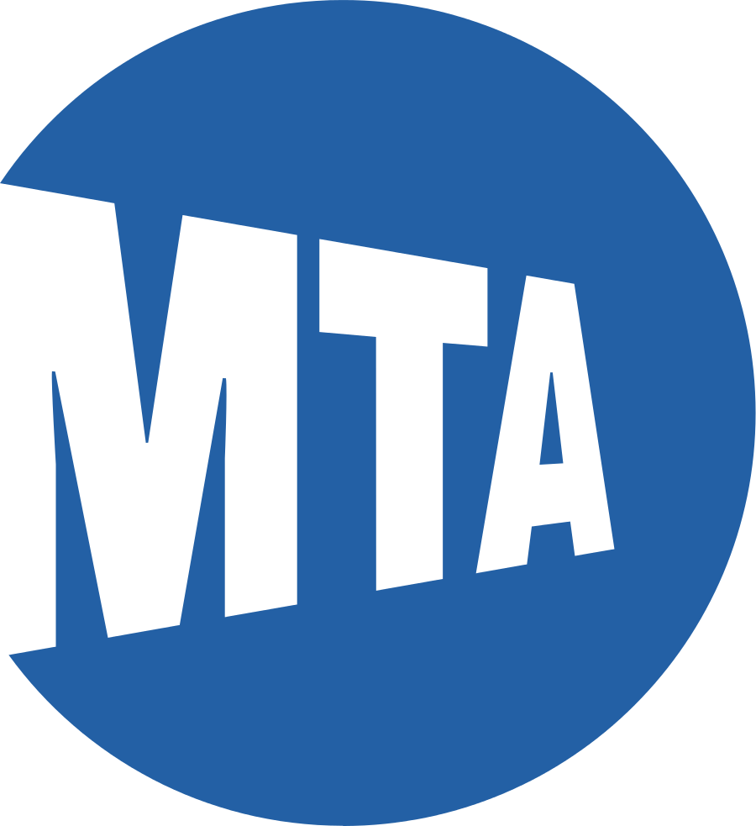

CTE For All
Brooklyn, New York Transit Tech HS
11th Grade
Electrical Installation

ISSUE
The current average age for workers in the industry workforce is 49 years old and above. Within 5 years, over 40 percent of these tradesmen will retire and take their valued skills with them. This could lead to a major issue for the MTA potentially limiting progress and service for New York City Transit. This is why it would be beneficial for the MTA to recruit more young people and women to join CTE fields.

QUESTION
How can MTA better encourage and recruit young people (and women) into CTE to prepare them for careers and technical fields?

COMMUNITY OF PRACTICE
- Instructor: Mr. Martinez
- Students: Genesis Rodriguez, Arsenio Rodriguez, Junior Rodriguez, Jermaine Mckenzie, Anthony Francis, Emma Adorno, Maiomie Rohoo
- Client(s): Patrick Smith, Toni Brown (MTA)

YOUTH DRIVEN DATA AND INSIGHTS
- Currently only 17% of MTA employees are females.
- 44% of employees in the MTA will retire within five years.
- 80% of the students in transit tech are interested in CTE.
- ONLY 10% of them knew of the CTE pathways in transit tech.

RECOMMENDATIONS
To attract more young adults to apply for CTE jobs the MTA can provide some incentives. These may include free metro passes for all high school students, Official MTA gear donations (clothes, power tools and etc.) and more internship opportunities. Overall the more MTA involvement with schools the more interest the students will show.

SHORT-TERM (1-6 Months)
Social Media
- We can go on social media as in Instagram, Facebook, also twitter and promote the MTA jobs by giving information on the requirements.
E-mail
- Send emails with a list of CTE schools to people signed up on social media.
Advertisements
- Ads are everywhere! Promoting transit tech and other schools' CTE programs to help get in to the MTA will increase peoples awareness about MTA jobs opening up.
MTA Jobs Apps
- MTA app would help show the different fields the MTA has to offer and the different salary.

LONG-TERM (1-3 Years)
Branding
- We have banners around the school that support the MTA and electrical careers.
Metro Card Holders/ Merchandise
- We can give out metro cardholders and key chains to encourage people to join the MTA.
School Websites
- Instead of having students create websites we should have professionals run them.
Brochures
- We place brochures in public places with MTA jobs information.

NEXT STEPS AND SHARED ACCOUNTABILITY:
- The city needs to target all schools to create more CTE programs.
- Students with CTE experience to volunteer for school fairs & speak to under classmen.
- Our schools needs to better inform the students about the opportunities available at Transit Tech
- Our project partner should create an action plan to bring our proposals to life.

