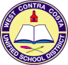
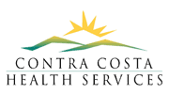
Improving Student Health at De Anza
Richmond, CA,
De Anza High School
10th Grade BioMed - Health Academy

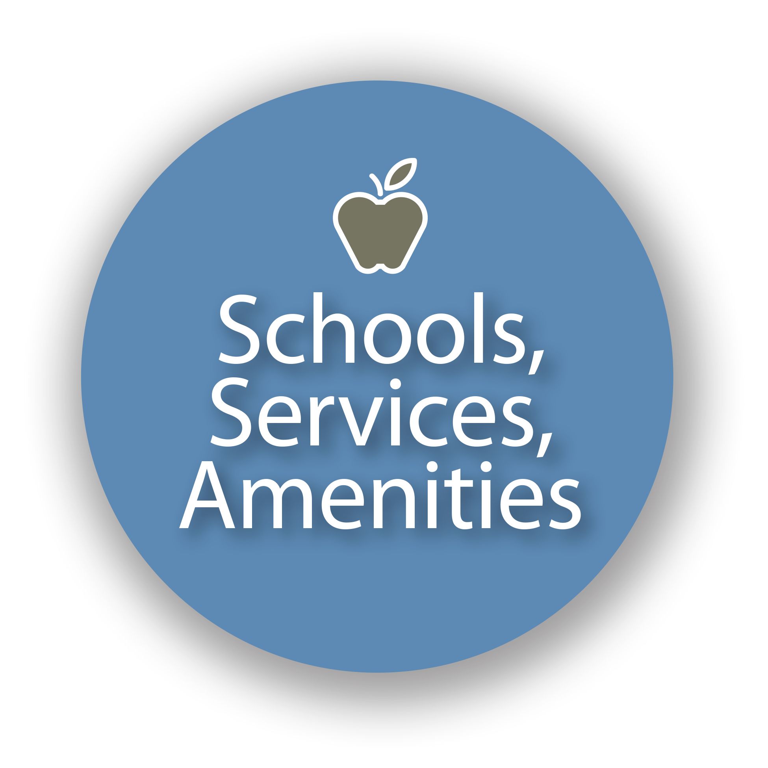
ISSUE
Schools that overuse punitive discipline and neglect the needs of the "whole child" increase the likelihood that their students, especially those of color, will become disengaged and more inclined to engage in at-risk behaviors that fuel the school-to-prison pipeline. This is a public health and equity issue. Contra Costa Public Health aims to promote "environments of opportunity" that reduce those social determinants of poor health outcomes. Schools can partner with public health and community agencies to provide prevention and wellness resources paired with opportunities to heal trauma-exposed youth and reinforce a safe, inclusive and equitable environment for learning.

QUESTION
What campus strategies and resources should De Anza High School administration and teachers prioritize to improve students' social, emotional and physical wellness and foster a healthy school campus climate?

COMMUNITY OF PRACTICE
- Instructors: Gabriela Abelman
- Students: Health Academy BioMed 10th Grade
- Client: Contra Costa Health Services and De Anza High School Principal
- Educational Partners: Richmond Promise and Center for Cities + Schools

YOUTH DRIVEN DATA AND INSIGHTS
Students created and shared an online survey to gather data from peers in order to better understand the issues faced by and the needs of De Anza students. They received 48 survey responses. The survey data is summarized below:

- About 30% of students have never visited the Health Center on campus
- 22% have never talked to a counselor on campus
- 41% of students surveyed rated the food quality a 1 (indicating lowest quality)
- Over 50% of students do 2-4 hours of homework each night, which is causing students stress.

RECOMMENDATIONS
- Improve School Lunch and Food Quality by:
  - Extend school lunch time and allow Open Campus / Off-Campus Lunch to allow students to eat whatever they want, without causing the school trouble.
  - Open a student kitchen, with culinary and agriculture classes.
  - Create a student garden on campus so students could pick and wash fresh and healthy veggies and fruits.
  - Partner with grocery stores and different organizations to get fresh veggies from there, or buy the misfit veggies and fruits that are unfortunately thrown away just because of how they are formed, their color, or shape.
- Increase College + Career Readiness by:
  - Providing more scholarships
  - Increasing diversity of options of electives to help students learn different topics, and help them decide what to study in their future (in college)
  - Starting a Driver’ Ed Classes to benefit students that are not able to afford the online classes to get their Driving Permit and still need access to school, jobs, and internships. The DMV could be a partner in this process by bring driving instructors and process permit tests
  - Hiring new teachers, purchasing needed materials, providing more field trips related to these classes
- Improve School Culture by:
  - Improving trust between students and teachers by considering alternative discipline strategies
  - Starting school later in the day so that our brains would be more awake later in the morning (9am instead of 8:10am). Students and teachers would benefit because we both would have more time to prepare for the rest of the school day.
  - Reducing homework to reduce stress and allow students more free time to do extracurricular activities, such as playing sports or spending time with family. Instead, give two large review projects each quarter or weekly quizzes to review what we learned that week.

LOOKING FORWARD: Next Steps and Shared Accountability
De Anza Principal will
- work with students and teachers to address the issues youth highlighted in their proposals.
- ensure all students know of services and resources already offered at De Anza High School.
- work to get more student leaders in current school committees to get more youth engaged in address school climate issues.
- commit to working with teachers to ensure “authentic learning” happens, through teacher co-creating curriculum and that engages student in

Contra Costa Health Services Department will
- teach Public Health Solutions curriculum to this cohort of students next school year, when they become 11th graders in the Health Academy, to broaden their health framework from direct medical services only to public health in the community.

De Anza Students will
- continue to spread awareness on these ideas and work together to improve the school.

