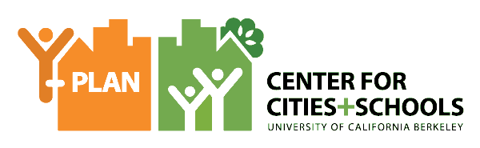

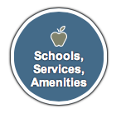

Increasing Healthy Food Access in Brooklyn
Brooklyn, NY
Life Academy for Film and Music
9th Grade

ISSUE
Food insecurity and access is one of the key issues facing Brooklyn. Many people in Brooklyn and NYC struggle to access fresh, healthy, and affordable food due in part to food deserts, where individuals travel more than a mile to access a full service grocery store.

QUESTION
How can students improve access to fresh, healthy, whole foods across the Borough of Brooklyn?

COMMUNITY OF PRACTICE
- Instructor: Katelyn Hunt
- Students: Dillion Johnson, Ravyn Browne, Amir G., Cheyanne Velez, Emily Chan
- Client(s): Deputy Borough President Diana Reyna, Deputy Policy Director Jeff Lowell

YOUTH DRIVEN DATA AND INSIGHTS
Community Survey in Bensonhurst around Life Academy High School
- “We found that it’s more than just access but a mindset that each person must have.”
Survey Results:
- 55% of students don’t feel as though they eat healthy.
- 25% of students don’t have access to healthy foods.
- 95% believe that damaging food is cheaper than healthier food.
- 55% of students eat fast food 2-7 times a week.

Site Mapping in Bensonhurst, Brooklyn
- “I think eating healthy is very essential to living however, many people do not have the resources or cannot afford to healthy.”
- “I know it’s necessary but I hate it, because it doesn’t satisfy me. I’ve never craved something healthy.”

RECOMMENDATIONS
SHORT-TERM (1-6 Months)
Healthy LIFE Mural
- Educate our school community and combat the fast food industries advertising tactics with our own “Heathy L.I.F.E.” mural to inspire our fellow students to make the right choices it takes to make healthy eating a way of life
- The mural will not only include images of healthy foods but healthy mantras. We hope that the students will be inspired by the mural and accept the mantras as their own.

LONG-TERM (1-3 Years)
Healthy Life Community Garden
- Create community service and home economic classes that allow the students to increase their skill and knowledge set of fresh fruits and vegetables.
- Provide the students with a natural environment, which is uncommon to their neighborhoods throughout NYC.
- We will also continue to partner with our clients Diana Reyna and Jeff Lowell, as well as Liberty Partnership Program to increase the possibilities and reach of the garden.

NEXT STEPS AND SHARED ACCOUNTABILITY:
- Trip to organic garden to learn how to cultivate a garden.
- Obtain funding for community garden.
- Continue “Healthy L.I.F.E” mural and educating our students on the benefits of eating healthy.
- Continue to research the lack of access to healthy affordable foods in urban communities.

