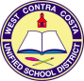
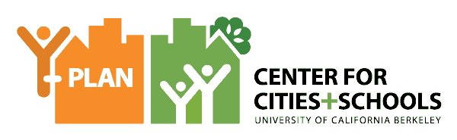
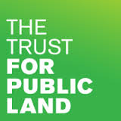
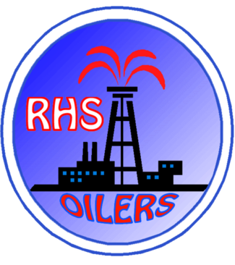
Planning a Youth-Friendly and Climate Smart Richmond
Richmond, CA,
Richmond High School
11th Grade English
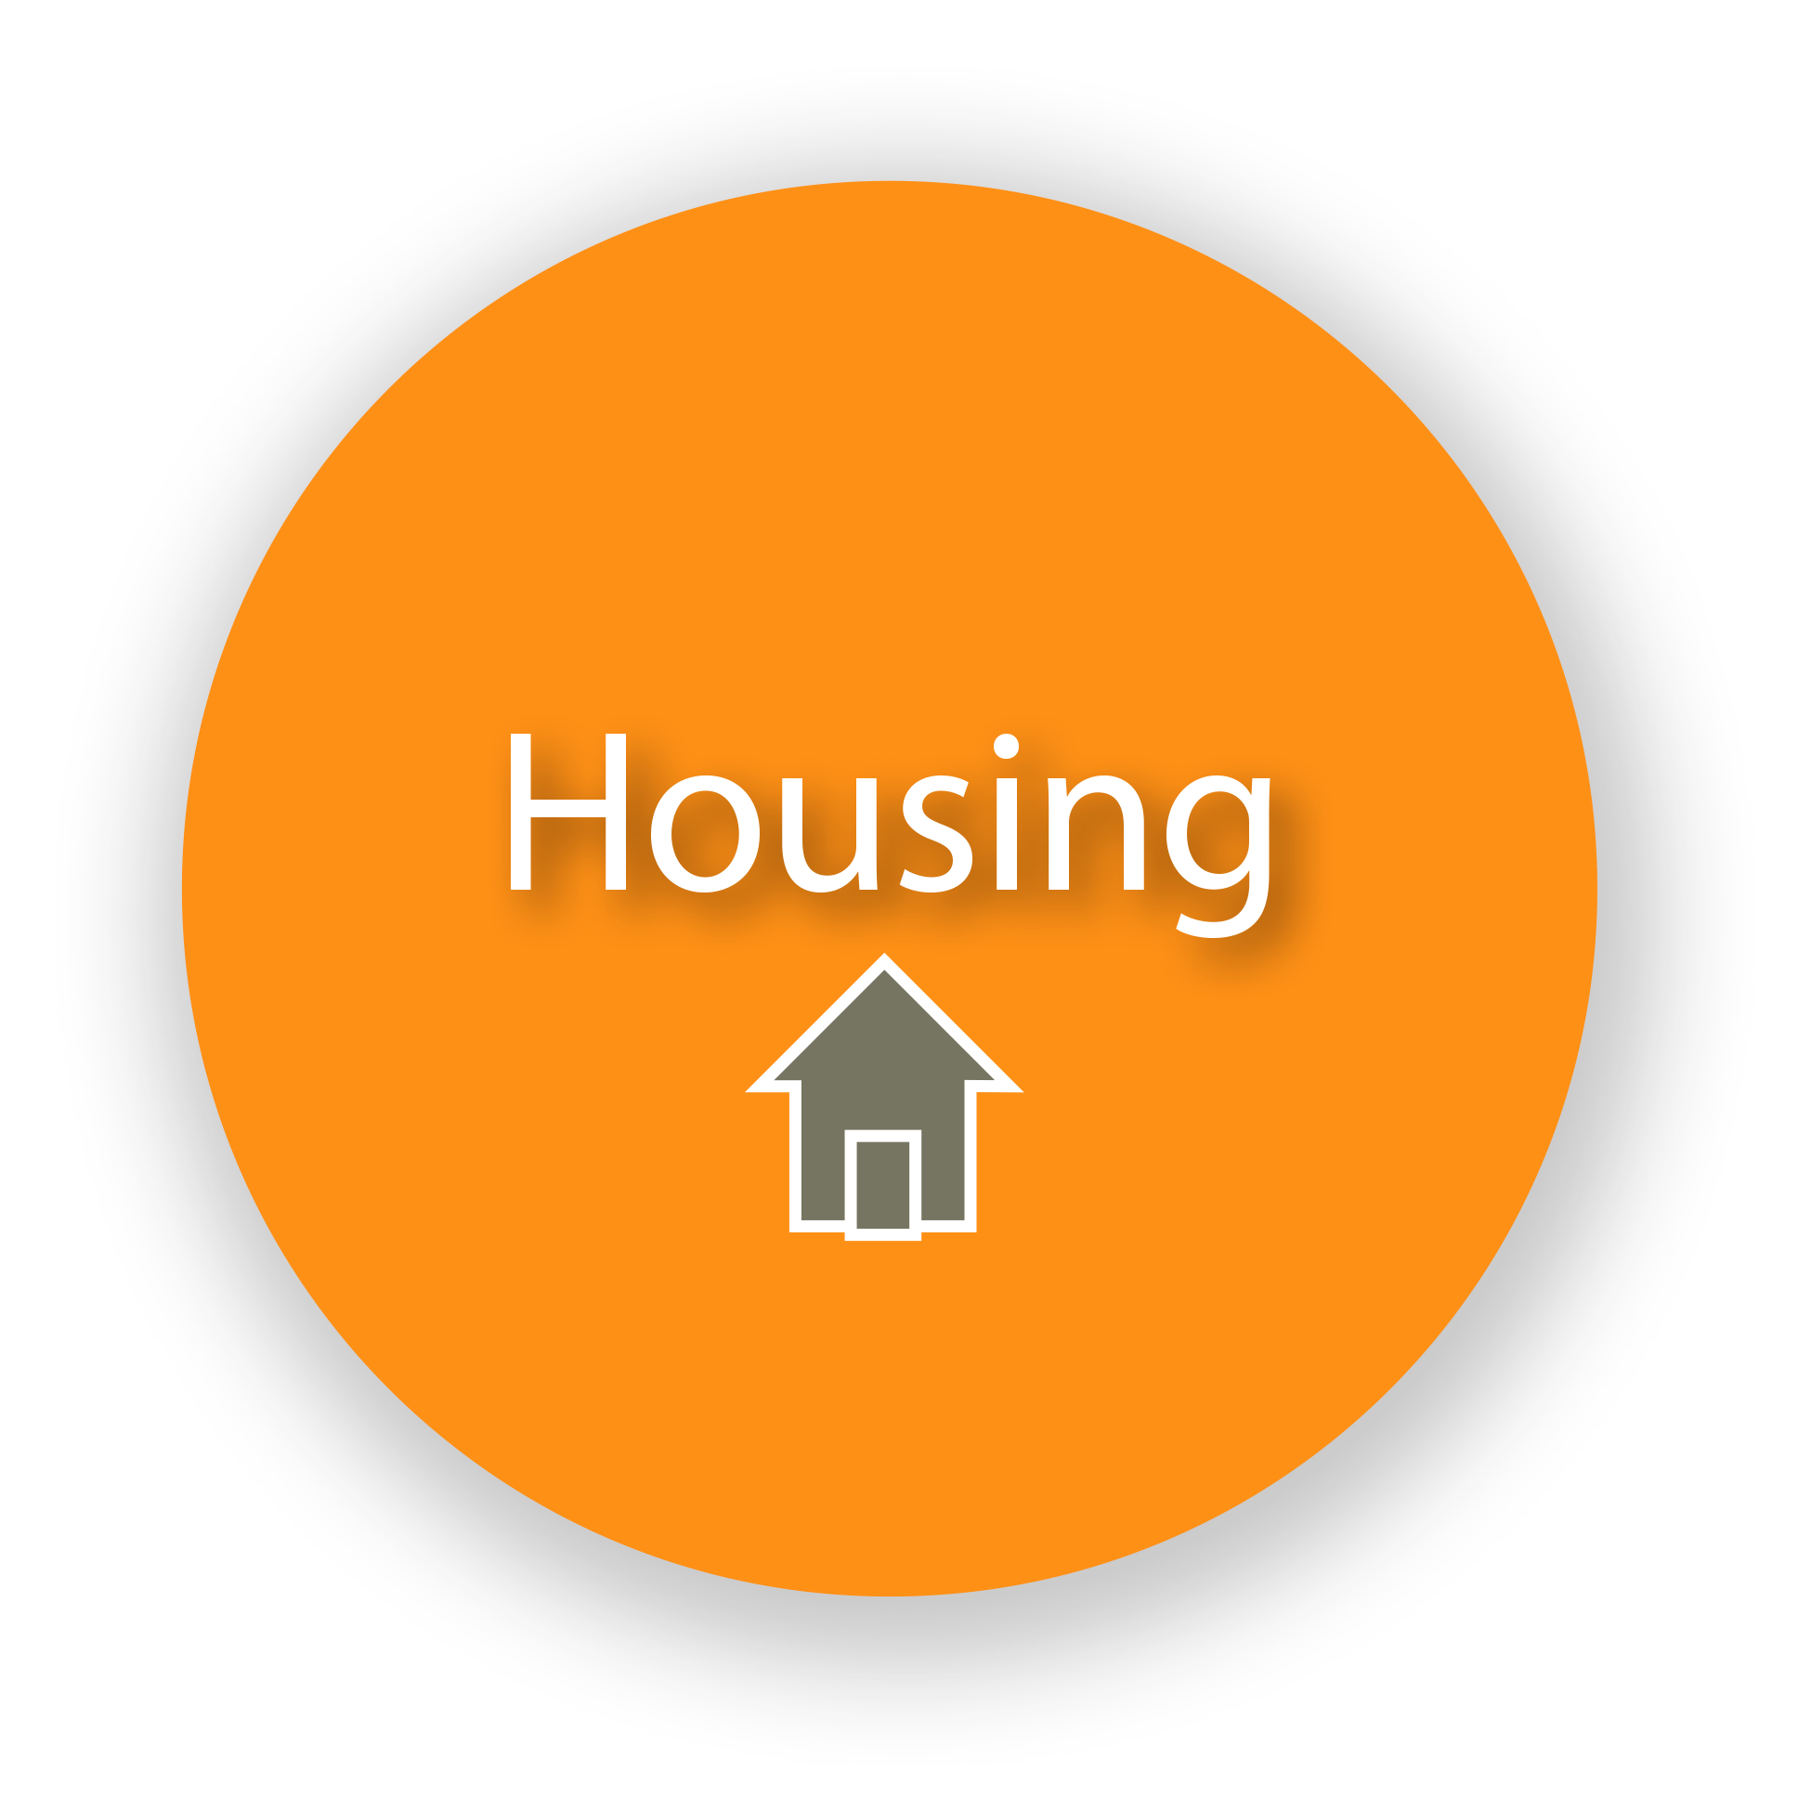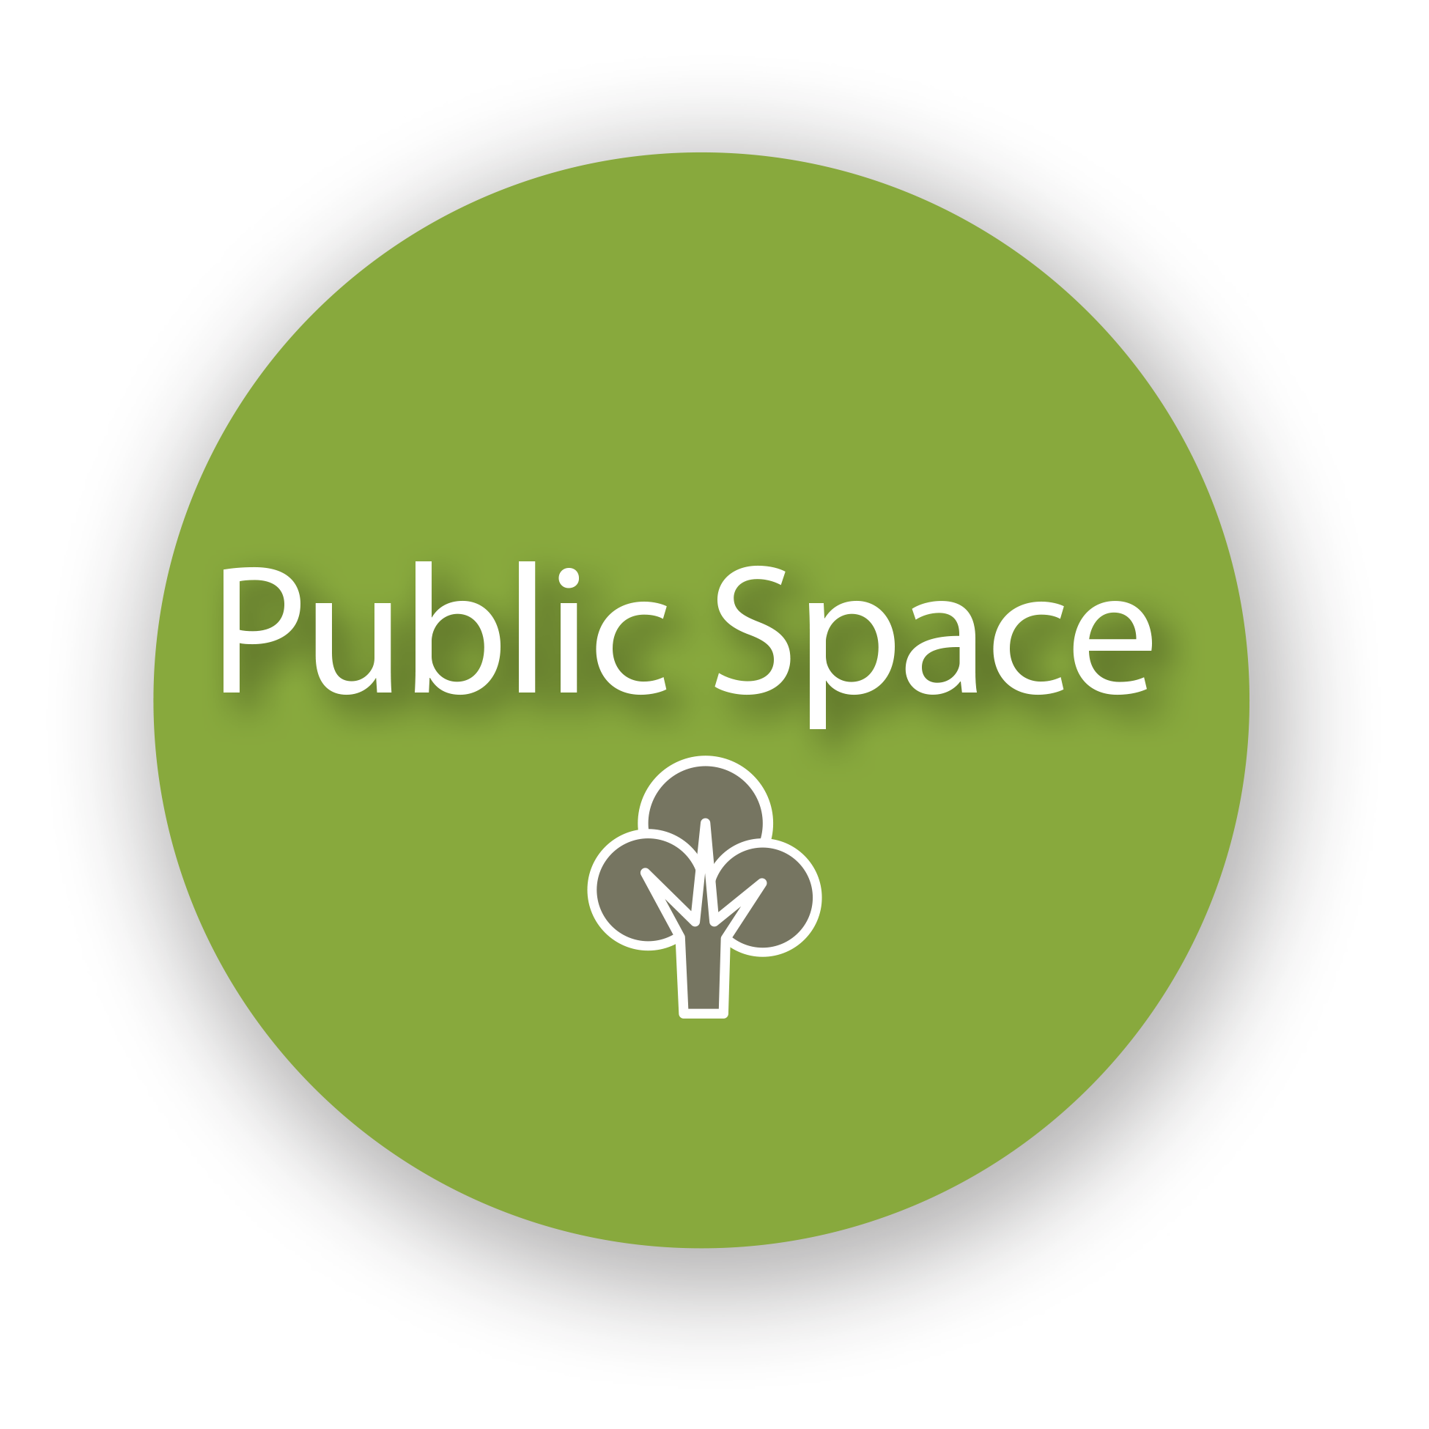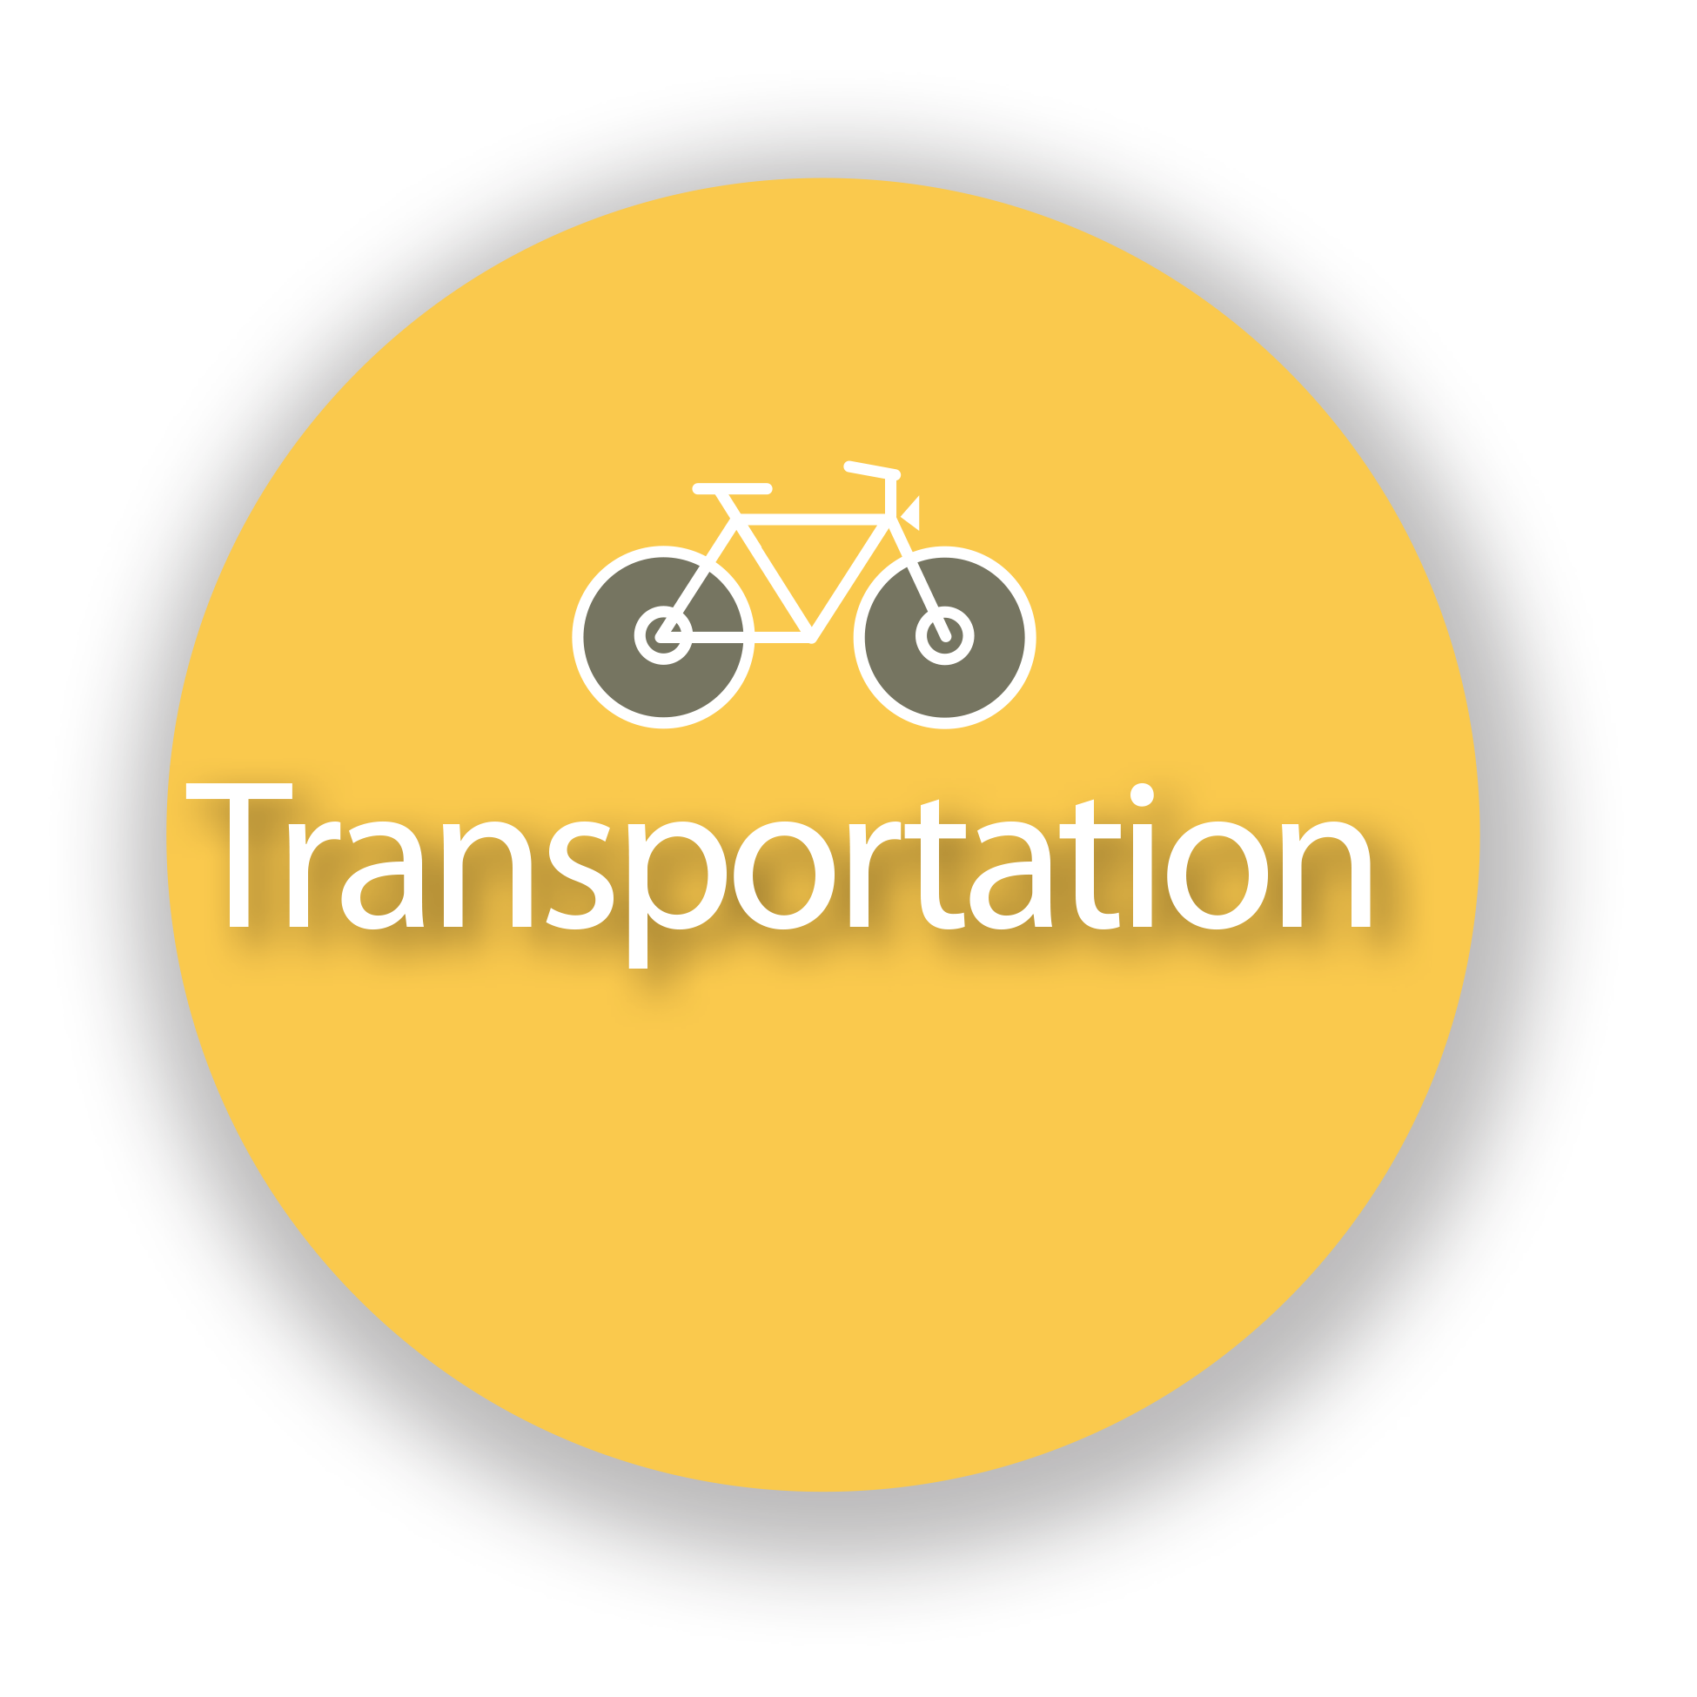
ISSUE
Cities are on the frontline of climate change. They can be an important part of the solution by offering energy-efficient living for our growing population—but they must also face the growing threat of heat waves and flooding. The Trust for Public Land’s Climate-Smart Cities program helps cities nationwide create parks and conserve land to meet the climate challenge and use parks and natural lands as “green infrastructure” serving four objectives: Connect, Cool, Absorb, and Protect. The Trust for Public Land and the City of Richmond recognize the importance of including youth perspective throughout the entire process, and reached out to the Center for Cities + Schools to leverage Y-PLAN to facilitate this inclusion of youth insight into Climate Smart Richmond from the start.
QUESTIONS
- How can the City of Richmond partner with its youth and families to strengthen its climate resilience?
- What youth-specific data should be included in TPL’s new GIS platform and how could this help achieve other benefits?

COMMUNITY OF PRACTICE
- Instructors: Rich Seeber
- Students: Health Academy English 11th Grade
- Client: Trust for Public Land and City of Richmond
- Educational Partners: Richmond Promise and Center for Cities + Schools

YOUTH DRIVEN DATA AND INSIGHTS
Students created and shared an online survey to gather data from peers that could shape their proposals for the City of Richmond. They received 95 survey responses. The survey data is summarized below:

- Medical Services are mostly obtained from Kaiser in Richmond, although some go to the Children’s Hospital in Oakland or use the in-school clinics.
- Youth indicated that parks, open spaces, and schools should be protected from climate change.
- Most obvious “heat islands” or “hot spots” for youth were bus stops and large parking lots.
- Youth want more public art around schools and on storefronts.
- Majority of youth either walk or get dropped off by someone else (parents, friends, Uber).
- Only 3% of youth regularly bike to reach their destination.
- Trash cans, benches, and lights with motion sensors are needed to protect the green spaces in our community.
- Most youth (76%) did have a grocery store within walking distance from their home. And still 73.7% said they eat out at least once a week.
- Most students agreed they wanted to see more parks around their neighborhood.

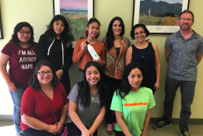

RECOMMENDATIONS
School-based
- Outdoor classrooms at RHS for green space appreciation
- Clean ceiling skylights inside school (to save energy)

Community-based
- Transform vacant lots around our school into public green spaces and parks
- More public and street art in the community
- Bus stop shelters with departure time display
- Construct complete bike lanes
- Reconstruct streets to prevent floods, especially at large crosswalks
- Street lights with motion sensors at parks and streets to have better lighting and to save energy

LOOKING FORWARD: Next Steps and Shared Accountability
CC+S will
- present a summary of student data at City Hall for TPL + City of Richmond representatives

Richmond High Students will
- support this summer’s Y-PLAN TOMODACHI Studio by providing 3-4 Y-PLAN Richmond Ambassadors.

The Trust for Public Land will
- continue to work with CC+S and Y-PLAN TOMODACHI throughout the summer
- create a youth-specific GIS data layer for Climate-Smart Richmond

